Implementation of DTL logic circuit as a NAND Gate
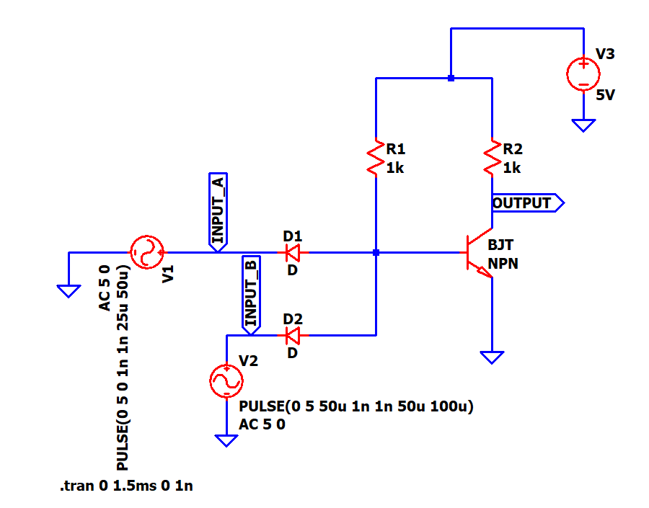
Figure 1: DTL-style circuit diagram showing the implementation of NAND gate

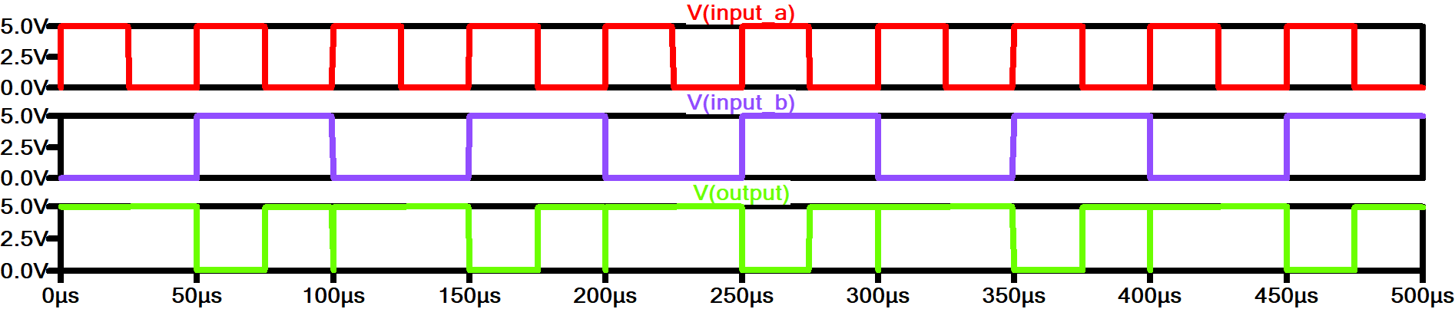
Figure 2: Simulation results showing the input signals (A, B) and corresponding output of the DTL circuit working as a NAND Gate

The Diode-Transistor Logic (DTL) circuit was simulated in LTSpice to verify the functionality of the NAND gate. In the simulation, two input signals were applied to the circuit, and the output voltage was observed. The waveform results confirm that the output remains high (logic 1) when any of the inputs is low (logic 0), and the output goes low (logic 0) only when both inputs are high (logic 1). These observations are consistent with the expected behavior of a NAND gate, thereby validating that the DTL circuit correctly implements the NAND logic function. The simulation also illustrates the response times and voltage levels, demonstrating the practical behavior of the circuit components.

